Reef
Guardian School Call for Action Eco Challenge

Teaching & Resource Guide

Eco Challenge Overview
Recent research has identified 100 Jobs of the Future that are likely to be created in the next few years.

This year’s Eco Challenge has been designed for students to explore the current and future issues facing the Great Barrier Reef through the lens of a future STEAM-focused role.

The aim of the challenge is for students to select a future job profile and showcase how they could apply their future skillset towards managing and protecting the health and longevity of the Reef.

The Reef 2050 Plan has outlined the '5 Priorities for Action' that need to be taken to help the Reef survive and thrive. Students will research one key threat facing the Reef and use their “future expertise” to come up with a plan to educate the public to take action.

The challenge is suited to students in grades 4 –11 but can be modified to suit your students’ age range. Students can choose to undertake this challenge by themselves or work together in teams as part of the school leadership program or club.

If working in a team, each student could select a different job profile and combine their “future skillsets” to address one of the 5 Priorities for Action.

The Challenge
- Pick one of the key threats identified in the Reef 2050 Plan to research.
- Choose one of the ‘100 Jobs of the Future’ listed in the ‘Resources’ section (or visit https://100jobsofthefuture.com/). In your chosen role, how will you use your future skillset to address the threat facing the Reef?
- Decide on a plan of action! Prepare your idea/proposal to using a poster, a power point, a computer-aided design, or prototype/physical model.
- Feel free to post your call for action on the Reef Guardian School Portal, Facebook page or email reefguardians@gbrmpa.gov.au and we will send you a token of recognition for participating in our 5 pillar C.L.A.S. = S (Care, Learn, Act, Share = Stewards of the Reef).

The PLAN OF ACTION must do two things:
- Address one or more of the ‘5 Priorities for Action’ from the Reef 2050 Plan
- Raise community awareness of the issue and use a Call to Action

The PLAN OF ACTION can take whatever form students’ desire! A poster, a prototype, an advertising campaign, a proposed invention – whatever medium students feel will best match their chosen job/action.

The Eco Challenge can take place in the classroom, or as an extracurricular activity for interested students.

Possible Assessment Criteria:
- Clearly addresses one or more of the ‘5 Priorities for Action’ from the Reef 2050 Plan*, demonstrating a thorough understanding of the nature of the threat to the Reef that the action addresses, and its role in contributing to the long-term protection and sustainability of the Reef.

- Appropriate selection of a “Job of the Future”, as demonstrated by clear and reasonable connections made between their chosen job and their proposed plan.

- Effectively communicates to their community the nature/purpose/importance of their chosen priority in a way that encourages a response or action from the audience i.e., does their proposal help to raise community awareness and/or engagement with the issues raised in the Reef 2050 Plan.

Document Summaries
100 Jobs of the Future: Overview
100 Jobs of the Future is a joint research project by Deakin University, Ford Motor Company, and Griffith University which aims to look at the future of work in an increasingly technology-driven society. The key findings of the project were that “the world of work will change dramatically in the next few decades. Even now, jobs are changing at a fast rate as machines and big data change the way we work and interact with each other… Climate change, population pressures and “technology” lifestyles will throw up major challenges for sustainability. New technologies and new materials will change agricultural practice, transport, engineering, and industry and business practices. Many, but not all, of the 100 jobs of the future will require scientific and technological and digital skills. Many also require people skills, creativity and imagination, and the ability to work across domains and to learn and adapt.” Visit the website to try the explorer tool, and for a more detailed description of the above roles, here 100 Jobs of the Future

Linking Future Jobs to the Eco Challenge
The Eco Challenge aims to turn those skills and interests outwards, into student’s future work and beyond, to encourage students to consider how their future jobs may work to serve and preserve the long-term sustainability of the GBR as a unique global icon, recognised as a World Heritage Area for its Outstanding Universal Value.

Reef 2050 Plan: Overview
The Reef 2050 report is about protecting the Great Barrier Reef in Australia, which is one of the most beautiful and important ecosystems in the world. The report outlines actions that need to be taken over the next 30 years to help the reef survive and thrive.
The report identifies five key threats to the Great Barrier Reef: climate change, water quality, coastal development, fishing and illegal poaching. To tackle these threats, the report calls for a range of measures including reducing carbon emissions, improving water quality, regulating coastal development and cracking down on illegal fishing.
The report also highlights the importance of working with Indigenous communities, who have lived on the land and sea around the reef for thousands of years, and have valuable knowledge and skills to contribute to its protection.
Protecting the Great Barrier Reef is important not just for the animals and plants that live there, but also for people who rely on it for food, recreation and tourism. The report recognises that the health of the reef is closely linked to the health of our planet and calls for urgent action to be taken to ensure its survival for generations to come.
Five Priority Areas for Action
- Limit the impacts of climate change by contributing to global efforts to reduce emissions and supporting the Reef and communities to adapt.
- Improve water quality by working with landholders, industries and communities to accelerate action to reduce the impacts from land-based activities.
- Reduce impacts from water-based activities by strengthening partnerships with Reef industries and delivering strong marine park management.
- Influence the reduction of international sources of impact to reduce marine debris entering the Reef from outside Australia and protect migratory species.
- Protect, rehabilitate and restore Reef habitat, species and heritage sites by minimising impacts from disturbances and assisting with their recovery.

Linking the Reef 2050 Plan to the Call for Action Eco Challenge
The Eco Challenge aims to encourage students to consider their efficacy and agency as individuals, community members, and global citizens, to take action to improve the Reef’s future – and further, to encourage others to also engage with issues facing the Reef, to support its health and resilience.

Bringing It All Together
Below are a few examples of how a few job profiles could be used to develop sample plans for action, which STEAM skills would be used, how it would match to the Priorities for Action from the 2050 Reef Plan, and ideas for how to present that plan.

Job Profile | Skills | Plan for Action | Priority Match | Production/Presentation
Biometric security solutions engineer | Science, design, technology, mathematics | Using specs inspired by cartilaginous fish/sharks/rays you design more energy efficient/safer modes of transportation | 1 & 3 | A physical model, or drawing.  OR use AI to develop hypothetical schematics.
De-extinction and conservation geneticist | Science/ethics, technology | Design/engineer new hybrid species of Reef animals. | 5 | Poster, painting, drawing OR use AI to develop the imagery.
Human Habitat Designer | Mathematics, design, engineering | Design multi-use food-producing playground on an existing lot of land next to the local creek or a community garden near a creek (which flows out onto the Reef) which considers rubbish disposal, composting, reef-safe gardening chemicals (fertiliser, pesticides etc), and doesn’t impinge on local wildlife (nesting crocs etc) | 2,3 & 5 | A large poster showing the design, with appropriate sections labelled. For added interaction there could be “lift the flap” sections.  OR  A 3-D model crafted from cardboard and recycled materials, or modelling clay.  Be sure to highlight all the features which make it beneficial to the GBR into the future!
Off-world Habitat Designer | Engineering, design | Design a mobile, under-water corporate office space for the Reef Authority. | 1, 4 & 5 | Taking inspiration from the Reef Authority’s website, use digital design technologies to create an “architectural plan”.
New Materials Engineer | Science, technology, design | Create more sustainable “reef wear” i.e., wetsuits and flippers made from recycled products. | 1 | Create an “advertisement” (could look like a magazine or TV ad, mock billboard etc), for a new sustainable reef wear fashion line – be sure to highlight all the sustainable features and benefits to the Reef!

Glossary
Key Terms | Definitions | Resources
Sustainability | NOUN  - the ability to be maintained at a certain rate or level:  "the sustainability of economic growth" · "the long-term sustainability of the project"  - avoidance of the depletion of natural resources to maintain an ecological balance:  "the pursuit of global environmental sustainability" · "the ecological sustainability of the planet" | GBRMPA ELibrary: Reef Beat education series: sustainability  Sustainability is a social goal about the ability of people to co-exist on Earth over a long time.  So, in everyday use, sustainability often focuses on countering major environmental problems. These include climate change and loss of biodiversity. They also include loss of ecosystem services, land degradation, and air and water pollution. The idea of sustainability can guide decisions at the global, national, and individual levels (e.g. sustainable living)
Invention | NOUN  - the action of inventing something, typically a process or device: | An invention is a unique or novel device, method, composition, idea or process.  Due to advances in artificial intelligence, the term "inventor" no longer exclusively applies to an occupation (see human computers)
Estuary | NOUN  - the tidal mouth of a large river, where the tide meets the stream. | Vulnerability-Assessment-Estuaries-2016 (gbrmpa.gov.au)  Pressures affecting estuarine ecosystems | State of the Environment Report 2020 (des.qld.gov.au)
Ecosystem | NOUN  - a biological community of interacting organisms and their physical environment:  "the marine ecosystem of the northern Gulf had suffered irreparable damage" | An ecosystem (or ecological system) consists of all the organisms and the physical environment with which they interact.
Responsible Innovation | Responsible Research and Innovation (RRI) is a term used by the European Union's Framework Programmes to describe scientific research and technological development processes that take into account effects and potential impacts on the environment and society | "ELSA"  gender equality  Engineering and Physical Sciences Research Council.  "Horizon 2020
Catchment | NOUN  - the action of collecting water, especially the collection of rainfall over a natural drainage area:  "water catchment continues the whole year round" | A drainage basin is an area of land where all flowing surface water converges to a single point, such as a river mouth, or flows into another body of water, such as a lake or ocean.
Climate Change | NOUN  - a change in global or regional climate patterns, in particular a change apparent from the mid to late 20th century onwards and attributed largely to the increased levels of atmospheric carbon dioxide produced using fossil fuels. | GBRMPA ELibrary: Reef facts for tour guides: climate change and the Great Barrier Reef  In common usage, climate change describes global warming—the ongoing increase in global average temperature—and its effects on Earth's climate system. Climate change in a broader sense also includes previous long-term changes to Earth's climate.  Climate change pressure on the Great Barrier Reef | State of the Environment Report 2020 (des.qld.gov.au)
Water quality | Water quality refers to the chemical, physical, and biological characteristics of water based on the standards of its usage | For the Great Barrier Reef, the main water quality issues are: Increasing sediment, nutrients and contaminants entering coastal waters in run-off from agricultural, industrial and urban land uses. Rising seawater temperatures and increasing seawater acidity associated with climate change.  Poor Water Quality - Great Barrier Reef Foundation - Great Barrier Reef Foundation
World Heritage Site | A World Heritage Site is a landmark or area with legal protection by an international convention administered by the United Nations Educational, Scientific and Cultural Organization (UNESCO). World Heritage Sites are designated by UNESCO for having cultural, historical, scientific or other forms of significance | Great Barrier Reef - UNESCO World Heritage Centre
Innovation | NOUN  - the action or process of innovating:  "innovation is crucial to the continuing success of any organization" | Centre for Marine Science and Innovation | School of Biological, Earth & Environmental Sciences - UNSW Sydney
Run-off | Runoff occurs when there is more water than land can absorb. The excess liquid flows across the surface of the land and into nearby creeks, streams, or ponds. Runoff can come from both natural processes and human activity. | GBRMPA-infograph-portrait.jpg (1169×1654)  Land-based run-off | gbrmpa  Land-based run-off pressure on the Great Barrier Reef | State of the Environment Report 2020 (des.qld.gov.au)  runoff (nationalgeographic.org)
Coastal Development | Coastal development is a broad category which includes an array of human activities including beachfront construction of homes, hotels, restaurants, and roads, often for tourism. Also included are things like beach renourishment, seawall construction, and nearshore dredging and oil platform construction. | Coastal development pressure on the Great Barrier Reef | State of the Environment Report 2020 (des.qld.gov.au)  Coastal Development & Sea Turtles — SEE Turtles
Try adding your own terms! | Can you find appropriate definitions… | …and resources?

Resources | Document/Website | Activity | Video
Engage | Reef facts | gbrmpa  GBRMPA ELibrary: Reef Beat education series: junior outlook | Eye on the Reef | gbrmpa  - Why not try the app?  - The Reef Discovery Online training course may be of additional interest.  KWL chart (provided below) | Visit the Great Barrier Reef | Great Barrier Reef Marine Park Authority - YouTube  GBRMPA ELibrary: Climate change and the Great Barrier Reef
Explore | 100 Jobs of the Future  The Reef 2050 Plan - DCCEEW  Reef 2050 Long-Term Sustainability Plan 2021-25 - DCCEEW  Cryopreservation - Great Barrier Reef Foundation - Great Barrier Reef Foundation | Browse: 100 jobs of the future  Great Barrier Reef case studies - DCCEEW  - This is a great launching point for students to explore current threats to the Reef, and what can be done about it.  Threats | gbrmpa  - As above | Education and awareness help protect the Reef - YouTube  Department of Agriculture Water and the Environment - YouTube  - Videos in this playlist may prompt students to explore environmental issues of the future more broadly.  Cryopreservation of corals on the Great Barrier Reef - YouTube
Explain | About Us - Great Barrier Reef Foundation - Great Barrier Reef Foundation  - The GBRF has some great ideas for how to get involved and/or imagine how to make practical change regarding innovation | 2011 Reef Beat Activity Book.pdf (gbrmpa.gov.au)  - Activities in this booklet link well with the Eco Challenge and may help prompt students in developing their own plans. | eReefs - Great Barrier Reef Foundation - YouTube
Elaborate |  | Development/construction of models, posters, designs.
Evaluate |  | Peer evaluate and finalise submission

The Eco Challenge is designed to work within an Inquiry-Based approach to learning and as such we suggest beginning the challenge by spending some time engaging students in the relevant content and concepts. Below are some suggested ideas:

Inquiry Stage: Engage (Week 1 of Challenge)
This is your opportunity to spark interest in your students, not only for the Eco Challenge but also for the Reef, and for the future. You may choose to do this by showing a clip, getting stuck into a Reef Beat poster or activity book, or an activity from our Junior Outlook, or by doing some good old-fashioned reading and research.

Key Questions for Inquiry Stage One:
- What is the GBR?
- What do you know about the Reef/what the Reef needs to “survive” (sea levels, temperature, water quality etc)?
- Who/what lives on the Reef?
- Who/what uses the Reef? Why is it important to protect the Reef?
- What are some of the main threats to the Reef and/or it’s connected ecosystems, now and into the future?
- What are some actions that individuals, groups, and governments do to protect the Reef?

Know | Want to know | Learned

Inquiry Stage: Explore (Week 2 of Challenge)
This is when you’ll start encouraging students to explore the gaps in their knowledge (as established in Inquiry Stage One, especially in the KWL). A great place to start is to investigate the following key areas: Current issues facing the Reef, Future issues facing the Reef, The Reef 2050 Plan, Jobs of the Future.

You may already be familiar with the above areas and might like to deliver that content to your students in your own way, we encourage your professional autonomy and responsiveness to the learners you have. Below are some key concepts to consider when engaging students in deeper exploration of the issues.

Begin your deeper exploration by encouraging students to engage in the relevant documents. Depending on the learner’s age/reading levels, you may like to read the document summaries or peruse the entire documents. See the resource list for a summary of the documents, and some examples of relevant jobs. We have also tabulated the key Jobs of the Future, the 5 priorities for Action, and provided examples of how these match/how students might connect them for the purposes of the challenge – see the resources list for this table.

Once you feel your students are comfortable with the overarching ideas, you might like to “test” the Jobs of the Future “Jobs Explorer Tool” by taking the online quiz. The explorer tool will help students to engage in the issues of the future, whilst also helping them explore their role in it.

This is also the stage where you will introduce the students to the criteria of the challenge in more detail, spending time ensuring they understand the task and how to tackle it. So, after spending time reviewing the documents, you should check for understanding with some simple comprehension questions (see below) and consider adding the answers to the KWL chart you started in Week One of the Challenge and/or creating a poster or signage that will help keep students focussed on the goal or simply display the one provided.

Key Questions
- Which of the 100 Jobs of the Future will you choose for this challenge?
- What are the 5 Priorities for Action?

Inquiry Stage: Explain (Week 3 of Challenge)
This stage of the inquiry is about students explaining their learning. With the end goal in mind of putting forth a plan for action, this would be the time where students would start to plan not only what they’re going to put together but also their ‘point’ – the WHY. Some activities to encourage their thinking and planning process would be to brainstorm their ideas of how a future job profile could link to a project that would meet the criteria of the challenge and call their community to action. Once they have all their ideas down, a follow up activity could be to collate or tabulate their ideas (see the Resource List for examples).

Once they have spent some time brainstorming and collating their ideas, a useful extension activity would be to have students explain their favourite idea/s to their peers for review, discussion, and feedback. Dramatic role play, imagining and Think/Pair/Share activities would be useful here also.

Inquiry Stage: Elaborate (Week 3/4, and through until Week 8/9)
During this stage students will invest time into “taking it further” or elaborating on their learning. This will look like the physical development and/or construction of any models, posters, designs and so forth. This is also a critical stage for ensuring that students are meeting the criteria – have they chosen a profile, considered the necessary skills, put forth a proposal for how to meet one or more of the 5 Priorities for Action, does it communicate this to the public?

Inquiry Stage: Evaluate (Week 9/10)
During this final stage of the inquiry, students will self-evaluate, peer evaluate and finally share their plans with the public.

Week | Inquiry Stage | Details | Suggested Activities | Notes
1 | Engage | Spark student interest in the broad issues | A.) Virtual learning  B)Videos  C.) Reef Beat  D.) Junior Outlook  E.) KWL
2 | Explore | Start researching | A.) Jobs of the Future  B.) Reef 2050 plan review | Create/ display poster listing jobs/priorities/ types of skills this job might require.
3 | Explore/Explain | Brainstorming ideas for how to approach the Challenge | Virtual Learning Experience with RGS Ed team on threats to reefs or Marine Careers
4 | Explain | Imagining, sharing brainstorming ideas | Role play future jobs  Student drafting
5 | Explain | Working on plan | Drafting – sourcing materials if necessary
6 | Elaborate | Creating | Student lead
7 | Elaborate | Creating | Student lead
8 | Evaluate | Peer feedback | Students provide each other feedback on their plans
9 | Evaluate | Self-evaluation | Students make changes and evaluate
10 | Evaluate | Share with the public for review | Submit to Reef Guardians

Australian Curriculum
The Eco Challenge has been developed by the Great Barrier Reef Marine Park Authority through the Reef Guardian School program to encourage inquisitive learners to explore topics of interest within the broad context of ‘protecting the Great Barrier Reef.’ The open nature of the challenge supports a variety of Australian Curriculum links and the United Nations Sustainable Development Goals that can be incorporated across multiple year levels. The following descriptions are included to guide the learning outcomes of the challenge.

Science Understanding
- Living things depend on each other and the environment to survive (ACSSU073)
- Living things have structural features and adaptations that help them to survive in their environment (ACSSU043)
- The growth and survival of living things are affected by physical conditions of their environment (ACSSU094)
- Interactions between organisms, including the effects of human activities can be represented by food chains and food webs (ACSSU112)

Mathematics - Statistics and Probability
- Identify and investigate issues involving numerical data collected from primary and secondary sources (ACMSP169)
Geography ‘Water in the world’ unit
- Classification of environmental resources and the forms that water takes as a resource (ACHGK037)
- The way that flows of water connects places as it moves through the environment and the way this affects places (ACHGK038)

Media Arts
- Plan, structure, and design media artworks that engage audiences (ACAMAM069)

Design and Technologies
- Investigate the ways in which products, services and environments evolve locally, regionally and globally and how competing factors including social, ethical and sustainability considerations are prioritised in the development of technologies and designed solutions for preferred futures (ACTDEK029)

English
- Use interaction skills when discussing and presenting ideas and information, selecting body language, voice qualities and other elements, (for example music and sound) to add interest and meaning (ACELY1804)
- Plan, rehearse and deliver presentations, selecting and sequencing appropriate content and multimodal elements to promote a point of view or enable a new way of seeing (ACELY1720)

Economics and Business
- Apply economics and business knowledge, skills and concepts in familiar and new situations (ACHES025)

Year 6 Student Exemplar of Eco Challenge
A group of our year 6 students formed a group called the 'Coral Crusaders', selected a future job profile and used their 'future expertise' to take action. Their message to the world is: We are all Reef Guardians. We are all responsible for taking care of the Great Barrier Reef!

Future Jobs: Additive Manufacturing Engineer; Drone Designer, Aerospace Engineer and Machine-learning Developer.

Task & Threat: Neutralise a current threat to the reef – the Crown of Thorns Starfish
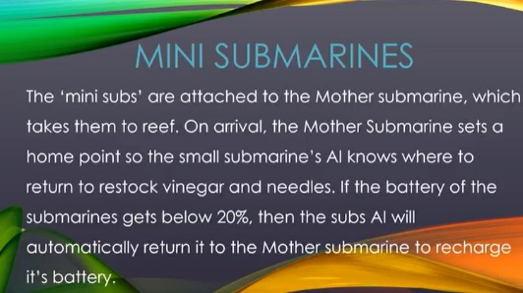
PowerPoint Slides:
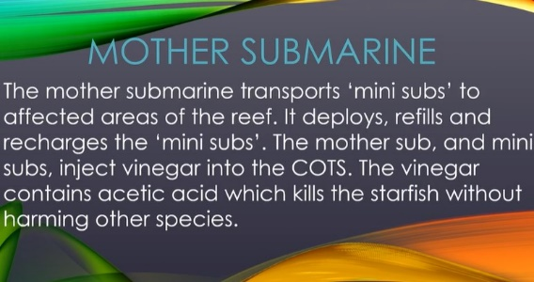

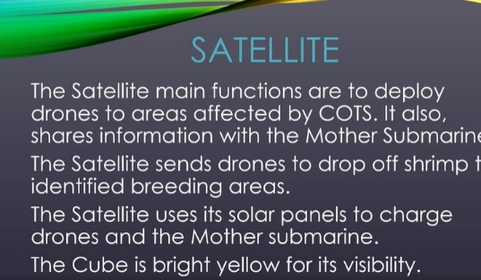
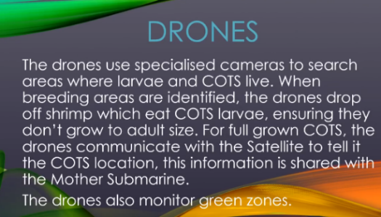

Accompanied Drawn Diagrams
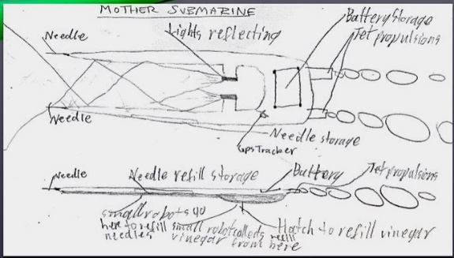
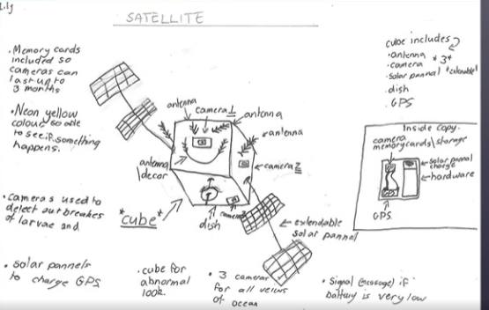

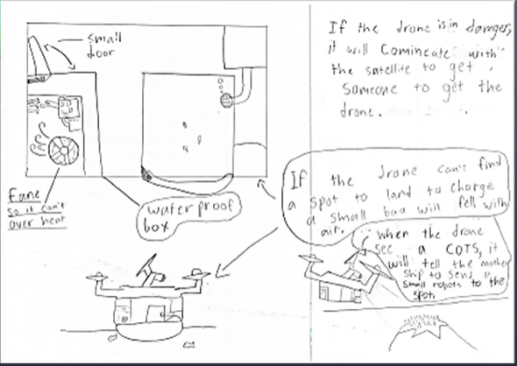
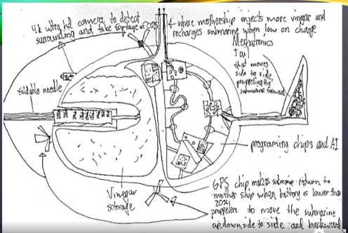

Year 6 Students, Magnetic Island State School
Senior year 11 Aquatic Practice Investigation Idea
Below is a QCAA assessment example designed by Gail Riches in 2023.

School Logo | Schol Name
 | Student name: Year 11 AQP Eco Challenge Example
 | Teacher name:
 | Date handed out: | Date due:

Subject | Aquatic Practices
Technique | Investigation
Unit | Marine Issues
Topic | Reef Guardian School Eco Challenge

Conditions
Duration | 8 weeks
Mode | Multimodal | Length | 3-5 minutes (max. 280 characters)
Individual/  group | Individual OR group (max. 4) | Other | Draft due: 4th Sept. & 4th Oct.  Final Due: Friday 13th Oct.
Resources available | 100 Jobs for the future  Reef 2050 Plan
Context
Eco Challenge Overview
Recent research has identified 100 Jobs of the Future that are likely to be created in the next few years.

The aim of the challenge is for you to select a future job profile and showcase how you could apply your future skillset towards managing and protecting the health and longevity of the Reef.

The Reef 2050 report is about protecting the Great Barrier Reef in Australia, which is one of the most beautiful and important ecosystems in the world. The report outlines actions that need to be taken over the next 30 years to help the reef survive and thrive.

The report identifies five key threats to the Great Barrier Reef: climate change, water quality, coastal development, fishing and illegal poaching.

To tackle these threats, the report calls for a range of measures including reducing carbon emissions, improving water quality, regulating coastal development and cracking down on illegal fishing.

The report also highlights the importance of working with Indigenous communities, who have lived on the land and sea around the reef for thousands of years and have valuable knowledge and skills to contribute to its protection.

Protecting the Great Barrier Reef is important not just for the animals and plants that live there, but also for people who rely on it for food, recreation and tourism. The report recognises that the health of the reef is closely linked to the health of our planet and calls for urgent action to be taken to ensure its survival for generations to come.

The Reef 2050 Plan outlines the '5 Priorities for Action' that need to be taken to help the Reef survive and thrive.

Five Priority Areas for Action (from the Reef 2050 Plan)
1. Limit the impacts of climate change by contributing to global efforts to reduce emissions and supporting the Reef and communities to adapt.
2. Improve water quality by working with landholders, industries and communities to accelerate action to reduce the impacts from land-based activities.
3. Reduce impacts from water-based activities by strengthening partnerships with Reef industries and delivering strong marine park management.
4. Influence the reduction of international sources of impact to reduce marine debris entering the Reef from outside Australia and protect migratory species.
5. Protect, rehabilitate and restore Reef habitat, species and heritage sites by minimising impacts from disturbances and assisting with their recovery.

The Eco Challenge aims to encourage you to consider your efficacy and agency as an individual, community member, and global citizen, to take action to improve the Reef’s future – and further, to encourage others to also engage with issues facing the Reef, to support its health and resilience.

Task
CALL to ACTION

You will research one key threat facing the Reef and use your “future expertise” to come up with a plan to educate the public to take action.

You can choose to undertake this challenge by yourself or work together in teams (maximum of four students to a team).

Your PLAN OF ACTION must do two things:
- Address one or more of the ‘5 Priorities for Action’ from the Reef 2050 Plan
- Raise community awareness of the issue and use a Call to Action

Your call to action must meet the following criteria:

• Clearly addresses one or more of the ‘5 Priorities for Action’ from the Reef 2050 Plan, demonstrating a thorough understanding of the nature of the threat to the Reef that the action addresses, and its role in contributing to the long-term protection and sustainability of the Reef.

• Appropriate selection of a “Job of the Future”, as demonstrated by clear and reasonable connections made between your chosen job and your proposed plan.

• Effectively communicate to our community the nature/purpose/importance of your chosen priority in a way that encourages a response or action from the audience i.e., does your proposal help to raise community awareness and/or engagement with the issues raised in the Reef 2050 Plan?
To complete this task, you must:
- Select and describe ONE key threat to the reef (climate change, water quality, coastal development, fishing, illegal poaching).
- Select and describe a future job profile from https://100jobsofthefuture.com/report/jobs/
- Showcase how your future job will fulfil one or more of the 5 priority areas for action.
- Make a Call to ACTION (encouraging your audience to act or respond).
- Present your call to action using a medium that can be shared on social media (e.g. video, poster) with a brief summary (max. 280 characters).
- Submit drafts and final by the due dates.

Checkpoints
☐ Term 3 Week 4: Task and task sheet assigned
☐ Term 3 Week 8: First Draft Due
☐ Term 4 Week 1: Second Draft Due
☐ Term 4 Week 2: FINAL Due
Achievement Standard

The student work has the following characteristics:
- description of one key threat to the reef and future job profile
- explanation of a priority area of action (in the 2050 Reef Plan)
- analysis of information to make a call to action
- use of language conventions and features to communicate the nature/purpose/importance of your chosen priority in a way that encourages a response or action from the audience
- generation of plans and procedures
- recommendations made

 | Standard A | Standard B | Standard C | Standard D | Standard E
Knowing and understanding | The student work has the following characteristics: | The student work has the following characteristics: | The student work has the following characteristics: | The student work has the following characteristics: | The student work has the following characteristics:
 | comprehensive description of one key threat to the reef and one future job profile | detailed description of one key threat to the reef and one future job profile | description of one key threat to the reef and one future job profile | superficial description of a marine issue or future job | partial description of a marine issue or future job
 | concise and coherent explanation of a priority area of action (in the 2050 Reef Plan) | coherent explanation of a priority area of action (in the 2050 Reef Plan) | explanation of a priority area of action (in the 2050 Reef Plan) | disjointed explanation of a priority area of action (in the 2050 Reef Plan) | statements of information about an action
[Dimension 2] | The student work has the following characteristics: | The student work has the following characteristics: | The student work has the following characteristics: | The student work has the following characteristics: | The student work has the following characteristics:
 | discerning and logical analysis of information to make a call to action | logical analysis of information to make a call to action | analysis of information to make a call to action | identification of information relating to a call to action | identification of aspects of information relating to a call to action
 | concise and coherent use of language conventions and features to communicate the nature/purpose/importance of your chosen priority in a way that encourages a response or action from the audience | coherent use of language conventions and features to communicate the nature/purpose/importance of your chosen priority in a way that encourages a response or action from the audience | use of language conventions and features to communicate the nature/purpose/importance of your chosen priority in a way that encourages a response or action from the audience | use of basic language conventions and features to communicate ideas and information | disjointed use of language conventions to communicate information
[Dimension 3] | The student work has the following characteristics: | The student work has the following characteristics: | The student work has the following characteristics: | The student work has the following characteristics: | The student work has the following characteristics:
 | generation of insightful plans and procedures | generation of considered plans and procedures | generation of plans and procedures | listing of aspects of plans and procedures | collection of information related to planning i
 | justified and valid recommendations made with detailed evidence | valid recommendations made with evidence | recommendations made | statements of opinion made | statements about aspects of activities made

Aquatic Practices: Oceanography Highlighted Syllabus Standard
Key: | Cognition | Qualifier
Appendix: https://100jobsofthefuture.com/report/jobs/

Technology jobs | Business and Law jobs | Urban jobs | Data jobs
1 Additive Manufacturing Engineer | 38 AI Intellectual Property Negotiator | 58 Automated Transit System Troubleshooter | 81 Algorithm Interpreter
2 Automation Anomaly Analyst | 39 Blockchain Talent Analyst | 59 Autonomous Vehicle Profile Designer | 82 Behaviour Prediction Analyst
3 Biomimicry Innovator | 40 Chief Ethics Officer | 60 Biofilm Plumber | 83 Data Commodities Broker
4 Bioprinting Engineer | 41 Community Farm Finance Broker | 61 Biometric Security Solutions Engineer | 84 Data Privacy Strategist
5 Child Assistant Bot Programmer | 42 Drone Airspace Regulator | 62 Human Habitat Designer | 85 Data Farmer
6 Digital Augmentation Officer | 43 Fusionist | 63 Integrated Energy Systems Strategist | 86 Data Storage Solutions Designer
7 Digital Implant Designer | 44 Innovation Manager | 64 Massive 3D Printed Building Designer | 87 Data Waste Recycler
8 DigiTech Troubleshooter | 45 Personalised Marketer | 65 Net Positive Architect | 88 Forensic data analyst
9 Energy and Data Systems Installer | 46 Real-Virtual Transfer Shop Manager | 66 Regional Community Growth Co-ordinator | 89 Freelance Virtual Clutter Organiser
10 Ethical Hacker | 47 Sharing Auditors | 67 Sustainable Energy Solutions Engineer | 90 Predictive Regulation Analyst
11 Gamification Designer | 48 Trendwatcher | Agriculture jobs
12 Integrated Home Technology Brokers | Environment jobs | 68 Agroecological Farmer | Experience jobs
13 Machine-Learning Developer | 49 Aged Persons Climate Solutions Consultant | 69 Bio-jacker | 91 Analogue Experience Guide
14 Mechatronics Engineer | 50 De-extinction and Conservation Geneticist | 70 Cricket Farmer | 92 Food Knowledge Communicator
15 New Materials Engineer | 51 Digital Apiarist | 71 Farm Safety Advisor | 93 Haptic Technology Designer
16 Quantum Computer Programmer | 52 Entomicrobiotech Cleaners | Space jobs | 94 Media Remixer
17 Robot Ethicist | 53 Flood Control Engineer | 72 Offworld Habitat Designer | 95 Multisensory Experience Designer
18 Robot Mechanic | 54 Integrated Ecology Restoration Worker | 73 Terraforming Microbiologist | 96 Space Tourism Operator
19 Satellite Network Maintenance Engineer | 55 Waste Reclamation and Upcycling Specialist | Health jobs | 97 Sportsperson of the Future
20 Shadowtech Manager | 56 Water Management Specialist | 74 Data-based Medical Diagnostician | 98 Swarm Artist
21 Smart Dust Wrangler | 57 Weather Control Engineer | 75 Genetics Coach | 99 Virtual and Augmented Reality Experience Creator
 |  | 76 Health Shaper | 100 Virtual Assistant Personality Designer
 |  | 77 Memory Optimiser
 |  | 78 Nanomedical Engineer
 |  | 79 Nutri-gutome Consultant
 |  | (‘Gut-bug keeper’)
 |  | 80 Virtual Surgeon

Year 11 Student Exemplar of Eco Challenge
Future Jobs: New Materials Engineer & Robot Mechanic.
Task & Threat: Provide food to corals and tend to coral gardens by ridding them of pests to help aid coral against coral bleaching.
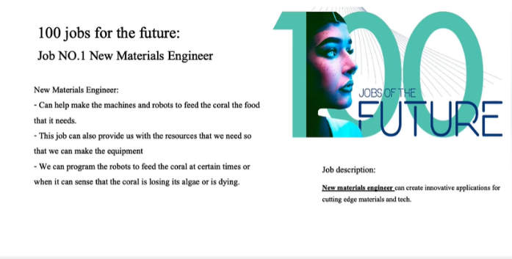
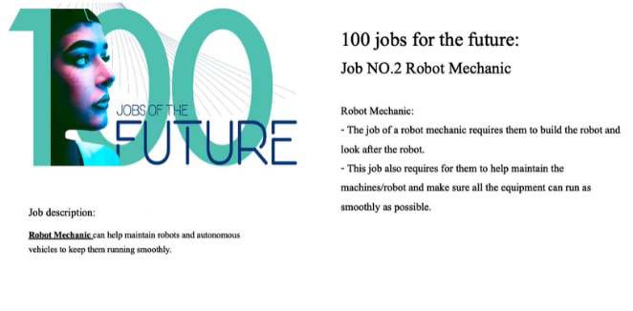
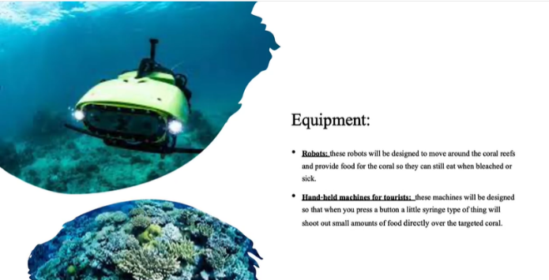
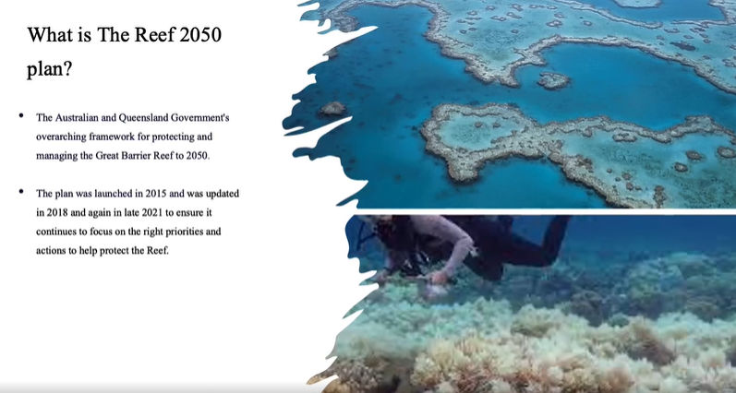
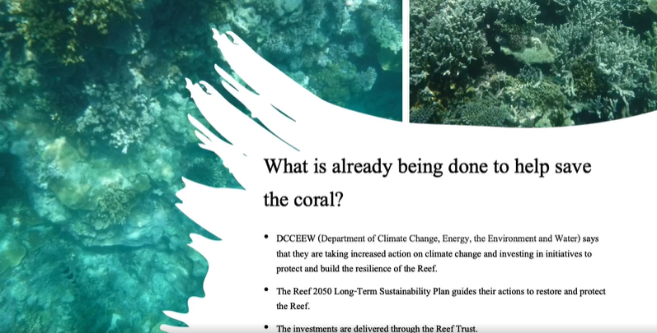
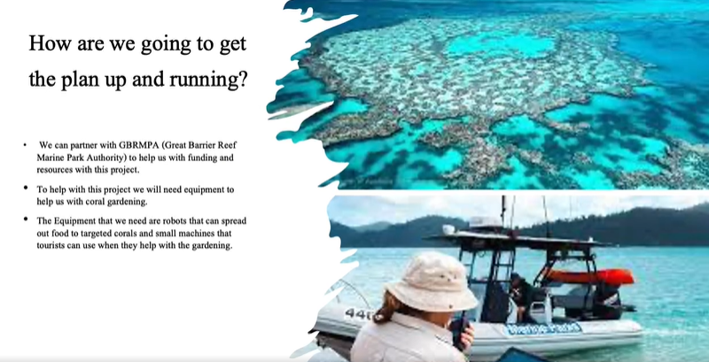
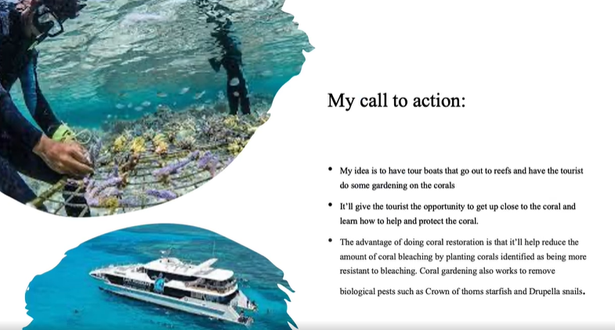
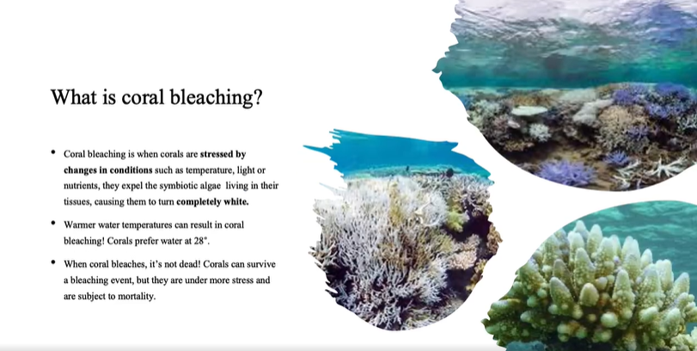
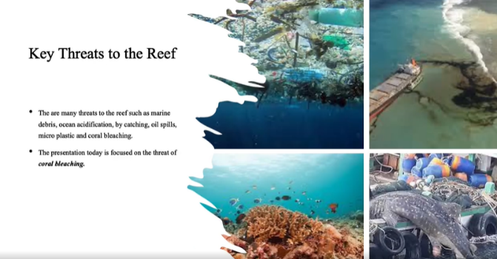
PowerPoint Slides
Year 11 Student, Trinity College Gladstone

